**ASSIGNMENT ON**

**PATTERN RECOGNITION AND MACHINE LEARNING**

In this assignment, you will apply PCA and Perceptron Neural Network to 2D axial images of the femur. The aims of the assignments are:

* To gain familiarity with the mathematics used to extract Principal Components and use those to recognize shape patterns using neural networks;
* To be able to apply the two techniques to medical images;
* To be able to critically describe the outputs of the two techniques.

Write a short report that answers to the following questions and tasks. Use the 10 MRI images of the femur you will find in the folder FemurImages.

**LANDMARKS**

Pick anatomical landmarks on each femur image using the function **landmarkPickingFemur.m**, following the example in the Figure below.

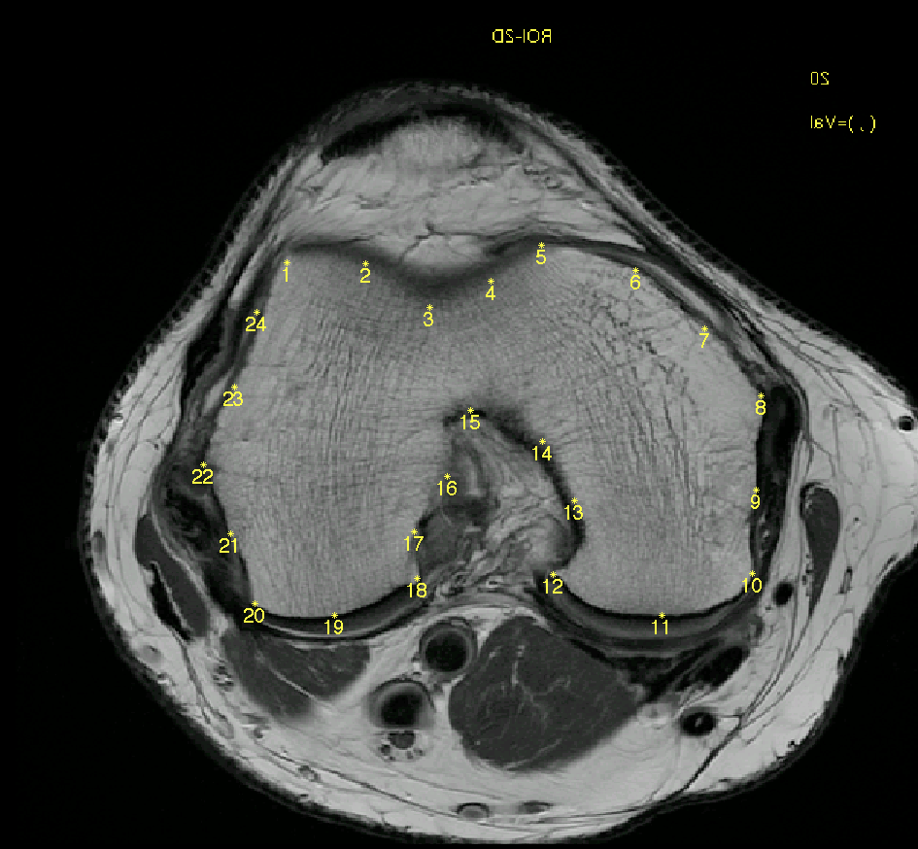

Q1:

* Which characteristics do the landmarks of different shapes have?
* Visualize the images with their landmarks (Insert figure in report)

**Unsupervised Dimensionality Reduction: PCA**

Calculate PCA on your data and analyze the output.

Q2:

Modify the code **SmileRecogntion.m** to work on the Femurs Dataset

- What is the PCA main goal?

* Which are the steps to calculate PCA?
* What are the outputs of PCA?
* Visualize the projected data on PC1, PC2, PC3 (insert figure in report);
* Visualize the mean shape and the shape variations for PC1, PC2, and PC3 using -3 and +3 as weights (insert figure in report);
* Which is the shape variation described by the first PC? And by the second PC? And by the third PC?

**SUPERVISED LEARNING**

Q3:

* Train a perceptron to recognize the females using a features vector that includes:

1. The coordinates of the landmarks (nD features vector)
2. The 1st PC (1D features vector)
3. The 1st ,2nd and 3rd PC (3D features vector)

(in the dataset each FemurN_F.png is a female and each FemurN_M.png is a male.)

* Evaluate the performances of the Nets with leave one out technique. Specify the percentage of misclassification.
* Include all the code in the report.
* Comment the results obtained

**General requirements**:

* Write short answers that directly reply to the questions;
* In the graphs, remember to specify title, x- and y-axis labels, and legend where appropriate.